**Collaboration**

We attach great importance to the communication with companies and iGEM teams. In this webpage, you can see that we have carried out in-depth cooperation in project installation, experimental design, wiki construction, etc. These cooperation have promoted and improved our projects.

. **BUCT**

**Collective Course**

To help team members better understand the iGEM, ZJUT-China and BUCT-China invited Xiaoling Tang, the director of the Zhejiang university of technology institute of college of biotechnology and bioengineering

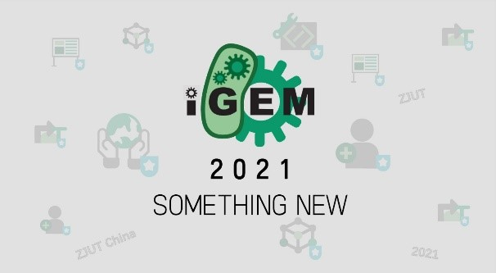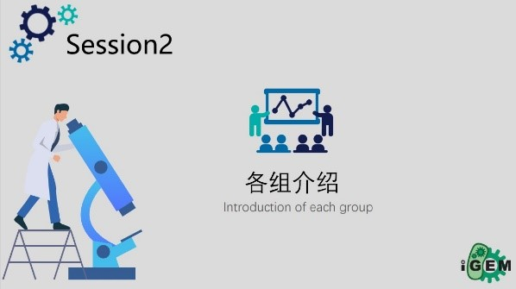

Professor Tang has extensive coaching experience, who had led a team to be awarded the gold prize. She introduced us the composition of iGEM website and the competition schedule, highlighting the emphases of each group. We benefited a lot from this course.

**Wiki Webinar**

We conducted a wiki webinar together with BUCT-iGEM. The webinar covered HTML and CSS basics, and also invited Yi Fan (the dry lab leader of ZJUT_China_B 2020) to explain the official requirements for wiki pages. The content of this webinar is a guide for students who are trying to learn web code (HTML and CSS).

The webinar is available online.

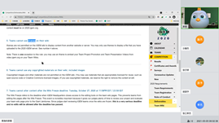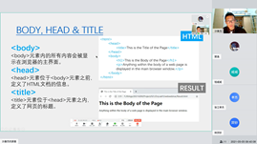

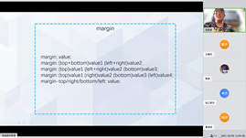

**SYSU-China**

This summer, we conducted online communication with SYSU-China team.

SYSU-CHINA use semi-rationally designed circRNA molecular scaffold to colocalize enzymes through the interaction between RNA binding proteins and RNA aptamers, for a higher rate of muti-enzyme reactions.

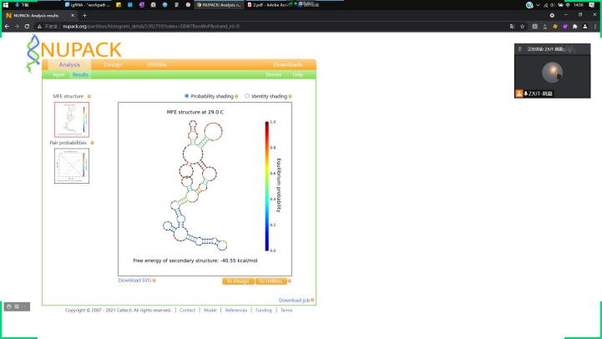

RNA designed by ZJUT-China

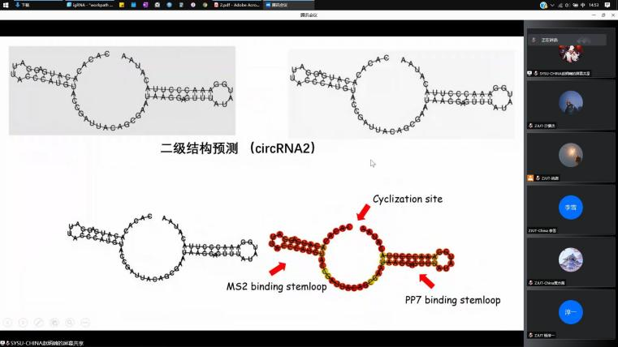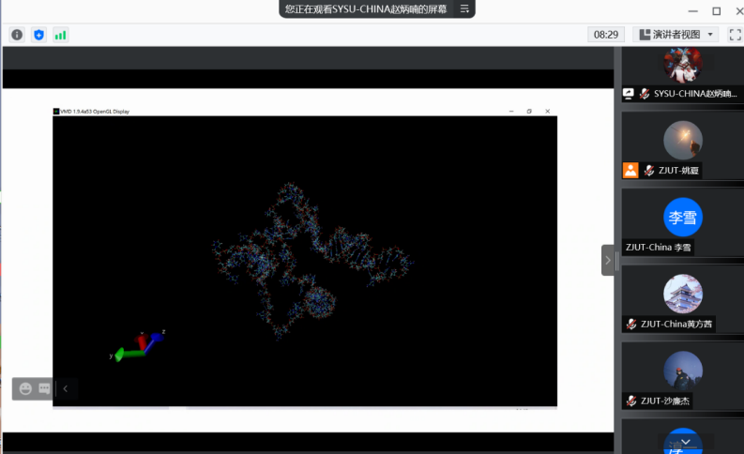

Circrnas designed by SYSU-China

Through communication, we found that both of our projects needed to transcribe RNA in vitro, which we had little experience in. SYSU-China gave us a lot of suggestions which helped us solved the problem of RNA degradation due to improper operation after in vitro transcription very well. Meanwhile, in our EMSA validation experiment, SYSU-China team suggested that we anneal the RNA to form its secondary structure which made it better to bind to cas9 protein. With their advice, our EMSA experiment was a success! Thanks for SYSU-China's help in our experiment.

We also made some suggestions for the SYSU-China team's RNA design. Initially, we hoped for more collaboration in the experiment and wanted to experimentally verify the RNA of SYSU-China. However, we found that the secondary structure obtained by NUPACK RNA prediction was too complex, and the stem-loop structure formed did not meet the requirements. In addition, through different software analysis, we found that SYSU-China RNA had a stem-loop structure that might affect subsequent experiments. In this regard, SYSU-China took our advice and improved its RNA sequence, and we also helped them complete the prediction of secondary structure.

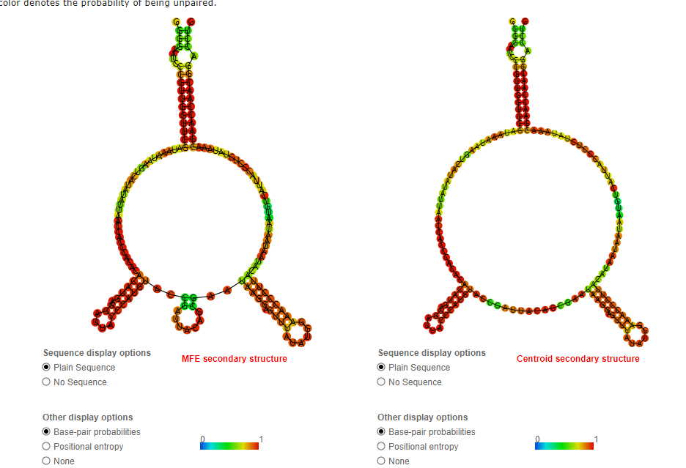

Predicted SYSU-China circRNA1 secondary structure by using Structure Editor

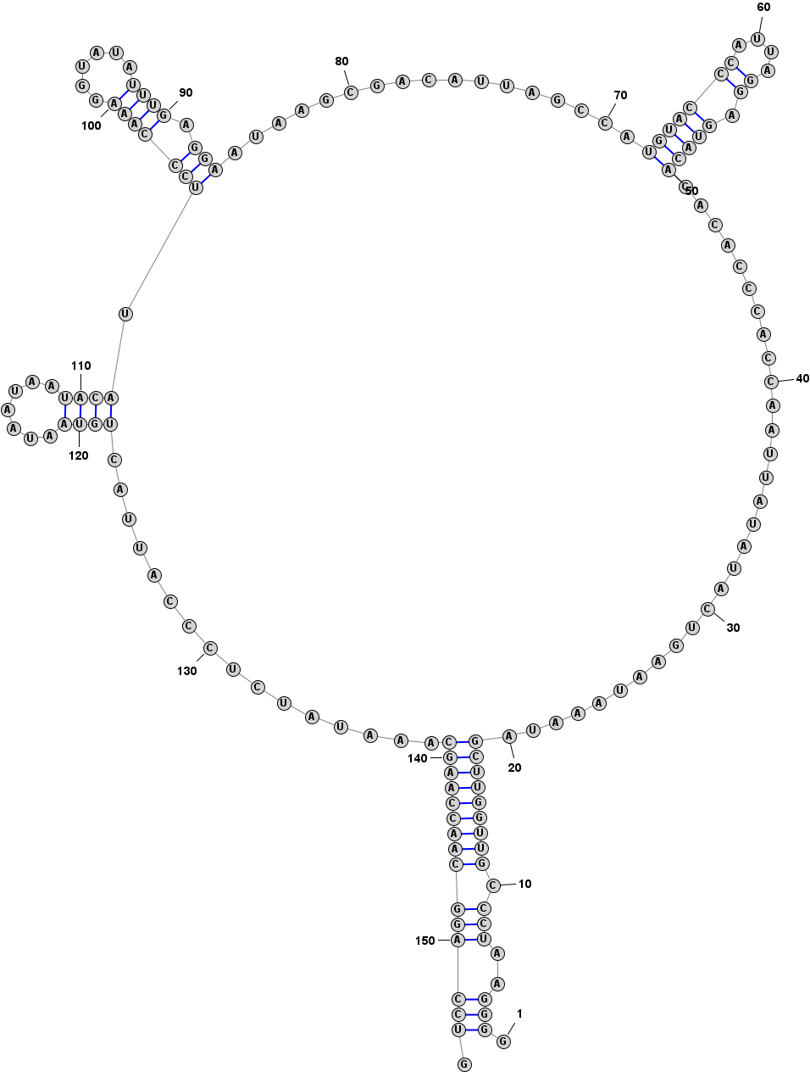

Predicted circRNA1 secondary structure of SYSU-China by using RNAfold 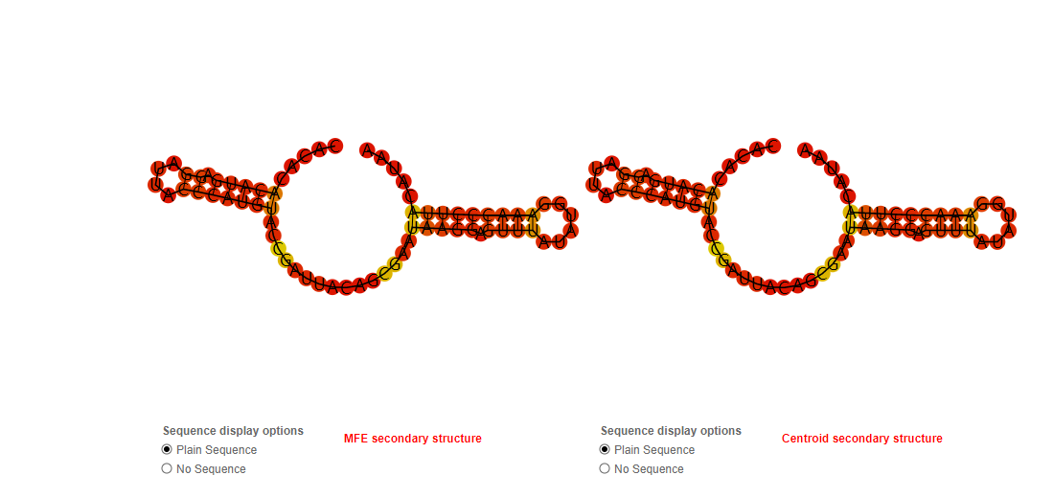

Predicted circRNA2 secondary structure by using RNAfold

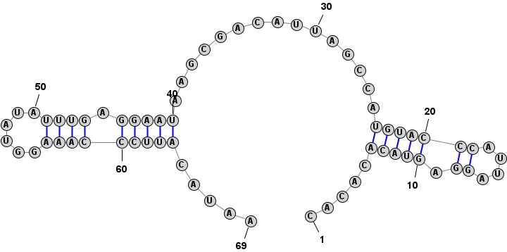

Prediction of circRNA2 secondary structure by using Structure Editor

**Jiangnan Meetup**

On May 29th and 30th, we joined in the 2021 China iGEM Online Meetup led by Jiangnan University, with 42 iGEM teams attended the conference. At the meeting, we listened to the project reports on four different topics. After the reports sharing, Jionglin Chen, secretary General of CCiC Executive Committee, gave a speech and predicted the 8th CCiC Conference to be held in Fudan University this year. Through this meeting, we had in-depth communication with other teams, and realized the general situation of CCiC and its development history, the status and role of CCiC in iGEM, and what kind of support and help each team can get from CCiC.

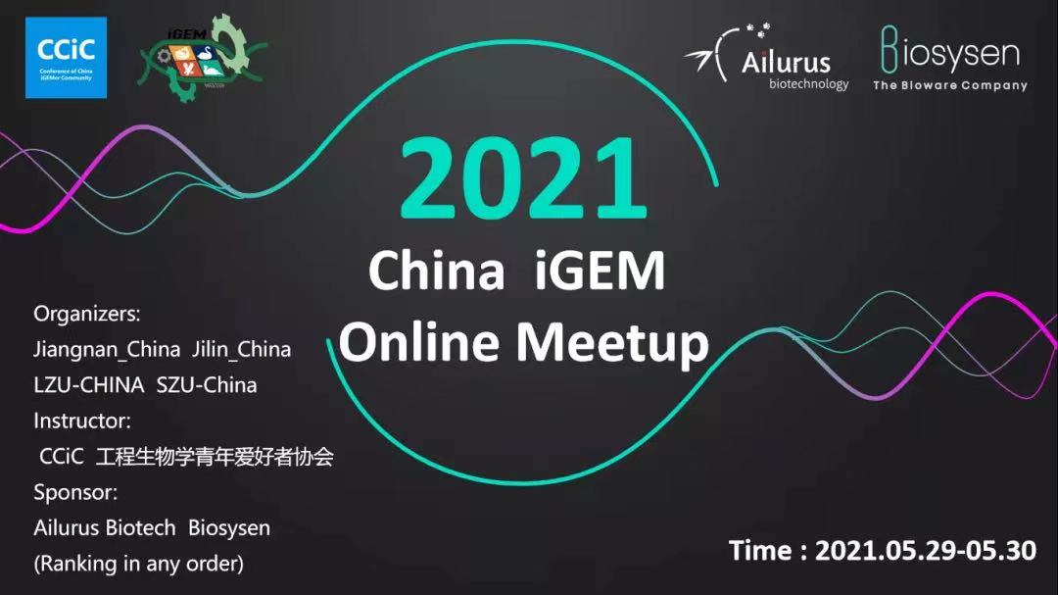

**2021 Hangzhou Meetup**

We joined SynBioMed Hangzhou meetup on July 15. In order to facilitate the understanding of information, ZJU-China contacted this meetup to promote the cooperation between teams in Hangzhou.

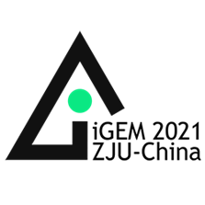

**CRISPR Webinar**

On September 11, the CRISPR conference led by Tianjin University was successfully held at Tencent Conference, with 11 iGEM teams from China participating in the conference. At the meeting, ZJUT - China team and each team had a deep and meaningful discussion, we also solve some problems of Northeast Forestry University, Lanzhou University, China Pharmaceutical University and the problems existing in the project for us put forward some suggestions, give us a profound revelation, and finally by the Tianjin University students sort out the CRISPR system application guide, to help the follow-up team.

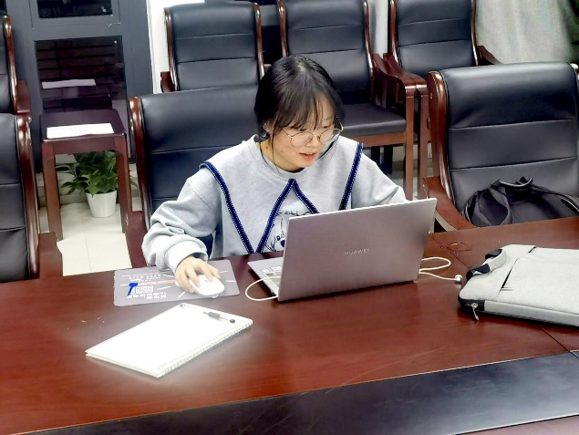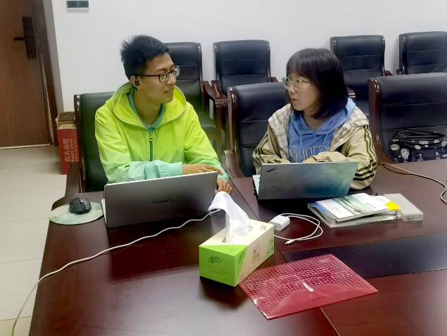

**CCiC**

From August 27 to 29, we participated in the 8th CCiC Conference on Synthetic Biology in Asia. The Conference of China iGEMer Community (CCiC) is a national summit independently initiated by iGEM teams in China. It aims to provide a platform for participating iGEM teams to share resources and promote mutual learning and communication. While listening to other excellent university programs, we also showed posters and promotional videos of our programs. According to the opinions of the judges and the project sharing of other universities, we received the affirmation of the project from many parties, and also identified the existing shortcomings of the project. Why cas9 proteins in CRISPR/Cas system are used instead of cas12 and Cas13 proteins, which are more suitable for detection, and how to solve the commonly missed target problems of Cas9.This will be the part we need to improve in the subsequent experimental design. During this conference, we were fortunate to communicate with other teams, such as BIT (Beijing Institute of Technology team), to solicit further cooperation.

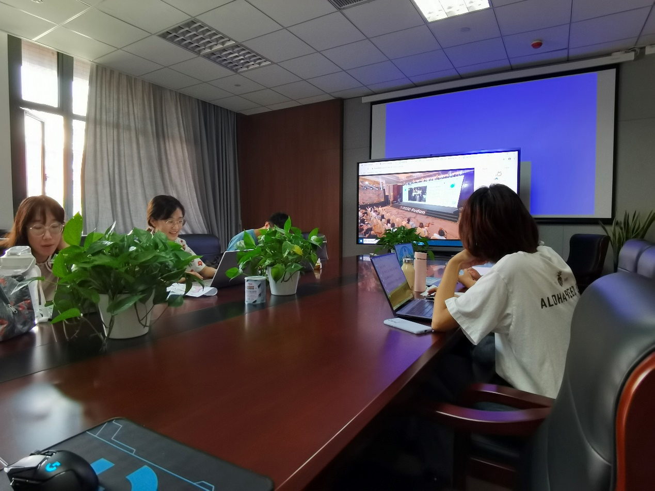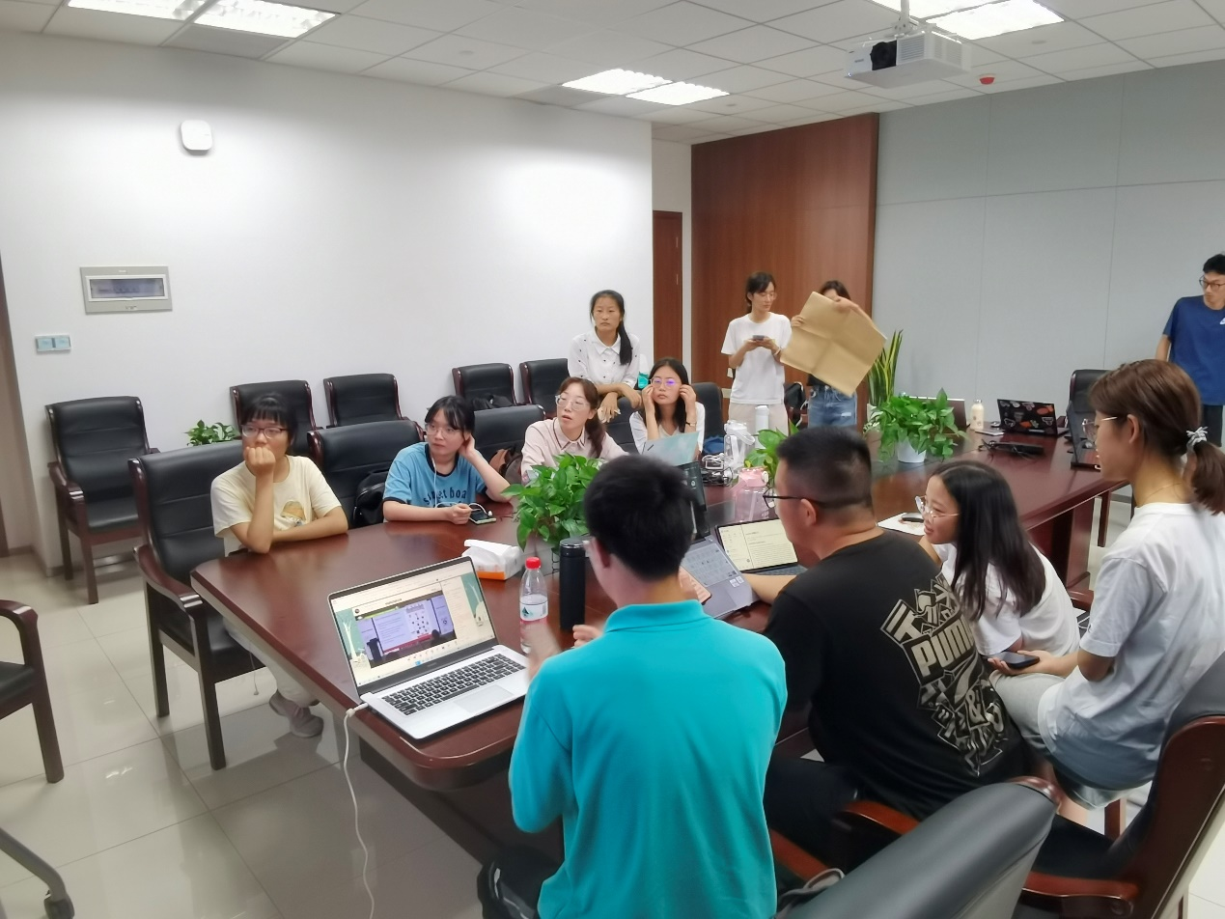

**Genscript**

September 8th, we were lucky to invite a technical consultant from GenScript Company to guide our project on how to proceed better. We consulted on the cutting activity of Cas9 and gRNA. Also，we have a further understanding of Genscript's related products, several different cas9 proteins, and their related roles, as well as cas12 and Cas13 proteins.

